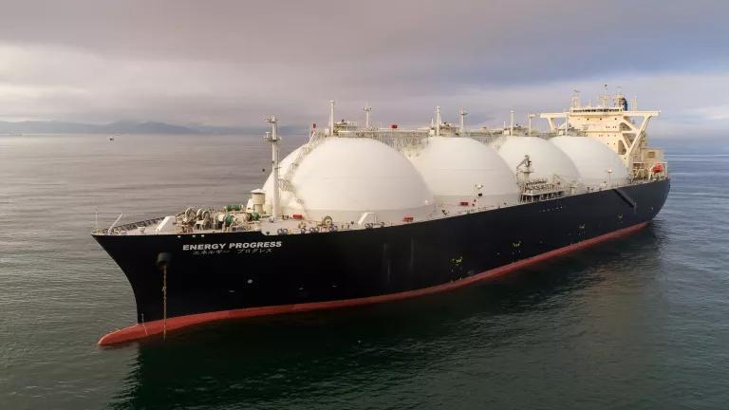

**Whitepaper on**

LNG value chain-Changing trends and commercial model

**November 2023**

1.Tushar Kant Tiwari

Senior Manager, Insights Factory- Energy

2.Harsh Kapoor

Manager, Insights Factory- Energy

Contributor:

Introduction

Natural gas is one of the major energy sources in the world and contributes to almost 24% of energy demand. Demand for natural gas has increased manifold in recent years. The massive rise in natural gas demand is observed since it is considered as transition energy source and less polluting than the other conventional energy sources. Natural gas production and consumption sites are spread geographically and transported through pipelines or LNG carriers. Asia and Europe are the major demand centers while US, Qatar, Australia, and Africa are the major natural gas supplier regions. LNG (Liquified Natural Gas) value chain is critical to cater to the demand for natural gas in different geographies. Considering the demand for natural gas, many energy companies plan to invest in the LNG value chain to extract maximum returns. Building up assets in the LNG value chain such as LNG liquefaction terminals, shipping, and regasification terminals would require huge capital. Companies' major challenge is to decide which commercial model to adopt for maximum ROI and sustainable revenue in the changing macro factors. The LNG asset capacity, capital structure, financing, offtake agreements, contracts, and pricing are critical in deciding which commercial model to choose. Companies make strategic decisions on whether to go for asset-heavy or asset-light, which plays an important role in the companies’ investment in LNG value chain. Also, there are better cases than one set commercial model for some companies interested in building LNG terminals.

# Abstract:

The whitepaper tries to analyze the varying trends and bring comprehensive view on the changing business environment in LNG value chain. The paper brings insights into the global supply and demand of LNG, different factors influencing natural gas supply and demand dynamics and tries to identify reasons for increasing LNG demand that help in deciding where to build LNG liquefaction terminal and regasification terminal.

The most critical for any business is to secure the revenue or return on the investments. Building an LNG liquefaction terminal is a capital-intensive project so securing the revenue is inevitable for the project's viability. LNG is like other commodities traded on long-term, short-term, and spot contracts. The paper will bring insights into how the companies in the LNG terminal business secure the LNG offtake for their terminals and highlight how the tenure of offtake agreements changes over the years. Traders and portfolio companies have different views on the contract and its tenure, and accordingly, they operate and conclude the contracts.

Decision on LNG pricing is critical and mostly not in the control of the energy companies. The paper brings insights into the pricing trends in different markets and highlights how LNG prices in different regions give an arbitrage opportunity.

The decision on capital structure while building an LNG liquefaction terminal is critical. The paper discusses the debt-to-equity percentage companies keep and showcases the trends. The financial institutions also influence the decision on capital structure. The analysis helps in deciding what capital structure to keep for companies planning to invest in LNG terminals.

The major commercial models prevalent in the LNG liquefaction terminal business are portfolio, merchant, and tolling. The paper discusses the complete analysis of commercial models and analyzes the IRR (Internal rate of return) companies can expect in each model. The paper also discusses the sensitivity analysis of each commercial model on changing variables such as capital structure (debt/equity), contracts (long-term and short-term), and LNG pricing. The analysis can help energy companies investing in LNG liquefaction terminals by providing IRR range in varying parameters.

Finally, the paper highlights the opportunities for energy companies at different points in the LNG value chain with changing trends and helps them make investment decisions. The paper also tries to align the PwC solutions for the companies in the LNG business.

# LNG demand and supply scenario

## Figure 1: Key LNG supply and demand markets by 2035, MMTPA*

**Asia to drive LNG demand, North America and the Middle East to remain lead suppliers.**



# Highlights

**Global demand and supply dynamics**

Demand highlights

* Strong Asian and LNG demands are the likely drivers for natural gas production, which could grow 48% to 5,900 bcm by 2050.
* An 80% drop in Russian piped gas flows to Europe led to a 60% growth in European LNG imports to 170 bcm (121 mtpa) in 2022.
* The global LNG market was 400 mtpa (560 bcm) in 2022, up 5.5% from 2021. But LNG trade value doubled from 2021 levels to a record $450 billion in 2022 amid the price spike following the Russia-Ukraine war.

## Figure 2: Liquefaction capacity growth by country/region over 2022-27, mtpa

### ChartThe US and Qatar lead liquefaction growth

**Key regionwide LNG project developments and downsides**

* New **US** liquefaction terminals should increase gas output to a record high of 100.67 bcfd in 2023. Projects may need 10–15-year offtake agreements to secure debt financing. Also, the DoE* tightened the extension requirements of LNG projects.
* **Canada’s** LNG export projects are more advantageously located to Asia versus USGC projects* and offer cargoes “as near perfect to net-zero as possible.” These projects will compete for Asian demand with US projects.
* **Qatar** is better positioned to demand centers versus North America but could suffer from regional geopolitical uncertainty.
* **China** and **India** will add regasification capacity as they transition from coal to meet climate goals. Chinese projects that source US gas could face issues if relations between the two countries continue to deteriorate. China received 57 new LNG carrier orders last year, which could be affected by the health of US-China relations.
* **Germany** has used FSRUs* as a stopgap solution to build new onshore LNG terminals to replace piped Russian gas.

# Managing contracts and price volatility

## The LNG prices experienced high volatility in the year in 2022. The supply went tight amid the Russia-Ukraine conflict in February 2022. This followed by Europe’s urge to offset Russian piped gas volumes with short-term LNG demand, coupled with government-push for energy savings, switch to the renewables and high inflation.

The growing geo-political uncertainty, price hikes led to sluggishness in demand across Asia, which accounts for over 60-70% of the LNG demand. The market witnessed slow procurement cuts from the major consumption centers such as China and India.

The price dynamics reflects significant changes in the LNG contract terms, which include price mechanisms and re-emergence of long-term agreements. Changes in these contracts, especially in response to the market, lead to different price trends and hybrid contract models. The oil-based indexation is prevalent in the Asian markets (e.g., Japan-Korea marker or JKM), while gas-index dominates across Europe (68% of the contracts), particularly in countries such as Belgium, Nederland, and UK, etc. (Title Transfer Facility (TTF) -linked pricing). Whereas in North America is 100% gas-to-gas competition (Henry Hub).

Some of the recently signed contracts for LNG supply especially the Mozambique LNG project, the offtake agreement has been signed by the counterparties basis both oil and gas indexed formula (Hybrid indexation), which can be represented as LNG prices = Weight A % x (Henry Hub price + Fixed Premium) + Weight B% (slope of oil index x oil prices).

The changes reflect in the trends as gap widens between Brent and LNG prices across Asia, indicating prices being moving away from oil-based indexation**. The LNG contracts are being equipped to deal with extreme price and demand volatility.**

## Figure 3: Price volatility and spread -TTF, JKM and HH (2017- 2023 Q1)

### Rise in prices post COVID was underpinned by for low carbon fuel in Europe and Asia, creating arbitrage opportunity for traders as well as portfolio players.

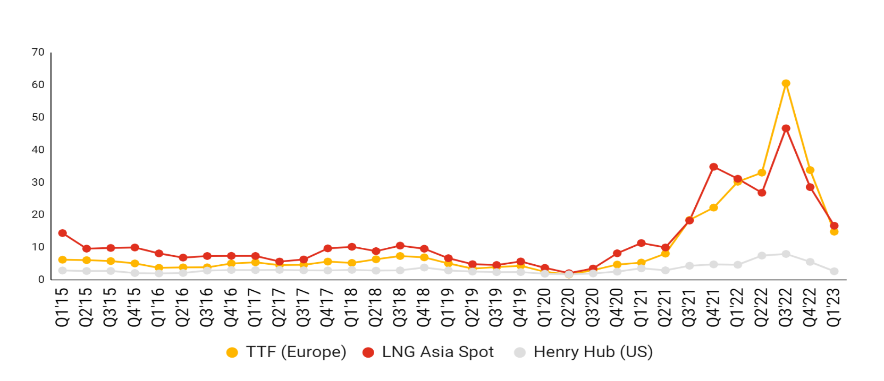

## Traditionally, long-term LNG contracts i.e., above ten years or beyond were signed between export LNG terminals and the LNG customers to safeguard the producers and customer interests. However, with increase in the natural gas production and demand in the market, the change in the duration of the contracts has been observed. Since 2010, short term contracts were 19% of total contracts, which has increased to 39% in 2020. Short-term and spot trades will continue to be a major part of the LNG market and will become increasingly dynamic, with flexible supplies from the US, Qatar and other regions competing for sales to high-value buyers. The US LNG will play a key role in the short-term/spot market in the near term, with other supply regions that had previously targeted sales into Europe forced to divert more volume to Asia Pacific. Also, the duration of long term which earlier considered 20 years and beyond has been reduced to 12-13 years average.

## Figure 4: Short- and long-term contracts historical trends (2010-2022)

### Short term and spot volume contracts have reduced in recent times, indicating uncertainties.

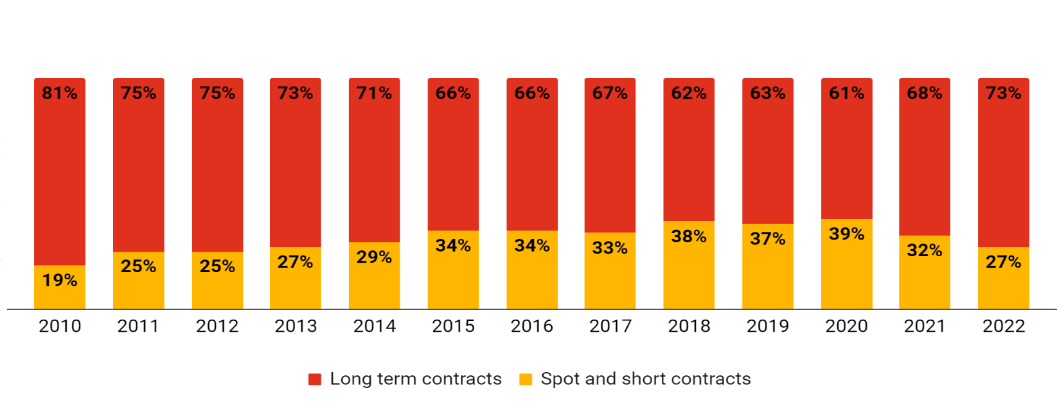

## Figure 5: Contract length by length

### Trends in contract length is in sync with price volatility, the median length of the LNG contracts in years.

**Long- and short-term contracts dynamics**

Trends shifts toward spot and short-term contracts.

* In Asia, only about one-third of LNG volumes are traded at spot prices, with the majority of LNG being priced against crude oil in long-term contracts.
* Long-term LNG contracts are being priced as a percentage crude oil index, known as the slope and a typical contract might be pegged at about 14.5% of the Japan Crude Cocktail (JCC), which is a price based on the customs cleared cost of crude oil in Japan.
* Approximately 60-70% of LNG globally is estimated to be sold via long-term contracts which typically run between 10 and 25 years. Medium-term contracts usually run for three to five years.
* A global goal of achieving net-zero carbon emissions by 2050 have left many countries unwilling to commit to such contracts recently, notably in Europe where spot and short-term contracts represent around 45%-50% of LNG trade.
* Shift to medium-term contracts should not be surprising, given the increase of trading companies taking long- term contracts as their business model which is maximizing value from market opportunities. many portfolio players like BP, TotalEnergies and Shell have been using their vast portfolios to do the same in recent years[1]. Portfolio players and traders targets to secure long-term LNG contracts.
* Asian LNG contracts equipped to deal with extreme price and demand volatility.

The correlation between TTF and Asian LNG spot prices increased from 0.86 in 2019 to close to 0.95 in 2020 which underscores the increasing linkages between Henry Hub and other regional indices.

* Brent-linked long-term LNG contracts are back in vogue. In 2022, the volume of long-term LNG contracts signed returned to its highest level since 2012, with 81 mmtpa of new LNG SPAs (sales purchase agreements) and HOAs (head of agreements) signed.
* Middle East exporters such as Qatar is reportedly asking for deals with oil price slope above 12.5%. These deals have limited flexibility, and seasonality and are fixed to a market. For example, the 27 year, Qatar-Sinopec deal starting in 2026, is speculated to have a slope above 12.75% with limited flexibility.
* While JKM has been widely used in spot contracts in Thailand and Singapore, long-term import contracts in Southeast Asia remain largely linked to oil prices, with some linked to gas hub indexes.
* Long-term LNG contracts have significant risks. E.g., for Japanese contracts, which are typically indexed to oil prices, when oil prices are high and LNG is plentiful, buyers locked into the contracts pay more than they would on the spot market. Therefore, such risks and contact terms needs to be worked out to ensure flexibility and minimal losses.

## Figure 6: Global LNG price-index distribution

### Brent-linked LNG contracts comprise major pricing index across the Asia-Pacific



## Figure 7: Price movements impacting contract dynamics and flexibility.

### The price difference between Brent and LNG widens post COVID, indicates deviation from brent linked contracts.

**Arbitrage opportunity**

LNG arbitrage occurs when the cost of shipping LNG between the markets is less than the price spread between those two markets. There has almost always been a spread between natural gas pricing in the US and Europe. Logistics is required to capture the opportunity.

**Table 1: Arbitrage opportunity**

### Rising prices create an opportunity to build asset-light business models by opting for short positions to benefit from trade margins or arbitrage.

|  |  |  |  |  |  |
| --- | --- | --- | --- | --- | --- |
| Year | HH Prices ($/mmbtu) | Shipping costs ($/mmbtu) | Total landing cost ($/mmbtu) | Asian spot prices ($/mmbtu) | Arbitrage spread  ($/mmbtu) |
| 2020 | 2.5 | 1.4 | 3.9 | 3.5 | **(0.4)** |
| 2021 | 3.0 | 1.1 | 4.1 | 4.4 | **0.3** |
| 2022 | 6.4 | 3.1 | 9.5 | 26.8 | **17.3** |
| 2023 | 2.7 | 2.2 | 4.9 | 16.7 | **11.9** |

*Note: all prices are averaged quarterly*.

**Emergence of portfolio players and traders capitalizing on the volatility**

A company that holds a portfolio of LNG supply from different regions as well as various shipping, storage and regasification assets. Portfolio includes a mix of long-term equity projects and mid-term and spot purchases. Volatility in gas pricing and supply has triggered a significant rise in long-term LNG supply contracting as nations work to weaken themselves off Russian gas and beat spot-price fluctuations. A key challenge for the market buying out of the US is that sellers need to secure 15-to-20-year contracts for financing purposes, where Western European buyers want shorter-term deals better suited to their energy transition schedules. Portfolio players and some new entrants have proved more willing to take that long-term risk. Trading allows the players to optimize the sale of their production by redirecting cargoes to markets with strong demand and higher prices.

Portfolio players and project equity holders are expected to control more volumes than consumers, with their share growing to 31% in 2025 from 24% in 2019. These players can capitalize on volatility. Trading houses such as Vitol and companies with LNG portfolios (oil majors) may seek to renew contracts and snatch up added volume from expiring agreements to fuel trading revenue. The LNG spot-price volatility to persist, underpinned by market dislocation, gradual tightening, a lack of gas storage facility in Asia and seasonality in power prices, as evident in Japan during winters. The portfolio players need to be better positioned to capitalize on volatility with flexible supply, enabling them to exploit arbitrage opportunities to boost profit. Recent months also stressed that unprepared buyers may suffer from price fluctuations. Portfolio contracts don’t specify the source or destination, so buyer and seller can choose locations that maximize profit. Shell, Total and BP each have sizable LNG portfolios.

Significant LNG contract expirations could lead to more flexibility and accelerate spot expansion, which would lead to more liquidity in the market and allow smaller participants to enter the market or expand as 20-year contracts and exceptional credit are no longer required, driving demand growth and supporting suppliers. Contracts that are re-signed will likely be for shorter durations of 5-10 years, or less, and have more flexible terms such as no destination restrictions.

The older contracts mainly had specified destinations. However, with the flexibility in the U.S. export contracts, portfolio players can direct cargoes where netbacks are highest, and buyers can divert cargoes depending on price and domestic demand. As per the market view, the long-term contracts signed between Qatar Energy and companies like TotalEnergies, Shell and Eni could be fully linked to gas hub prices instead of a hybrid pricing formula as it reflected the price relevant for downstream marketing of natural gas.

**Table 2: Profile of key LNG players**

### Portfolio players leverage arbitrage opportunities due to their robust merchant portfolio.

| Type | Player | Volumes handled | Comments |
| --- | --- | --- | --- |
| Portfolio player | bp | * Current 15 MTPA (2022) * bp aims to double its LNG portfolio by 2030 to 30 MTPA. | * bp[2] has built up more merchant LNG in its portfolio in recent years by agreeing on offtake from projects where it does not hold equity. * bp's current LNG portfolio of 15 MTPA is divided between equity and merchant volumes in a roughly 50:50 ratio. |
| Portfolio player | Shell | * Shell delivered 70 MTPA of LNG and has a fleet of 60 carriers. | * Shell is the world’s largest LNG trader. * LNG trading division[3] recorded a nearly $1B loss in the third quarter of 2022. * Shell plans to invest in competitive LNG assets with a technical cost of less than $5 per mmbtu[4]. |
| Portfolio player | TotalEnergies | * Handled 34 MTPA in 2019. * Target 45 MTPA by 2025. | * Portfolio[5] focused on Asian markets such as China, India, South Korea, Japan, and Taiwan. |
| Portfolio player | Exxon Mobil | * ExxonMobil, through its affiliates and LNG joint ventures, produces 23 MTA of LNG globally and, with LNG suppliers, delivers to 30 countries. | * Exxon has an interest in over 74 MTPA of liquefaction capacity. * The company aims to create a global trading arm[6] as a part of its reorganization strategy to compete more aggressively with BP and Shell. |
| Portfolio player | Conoco Phillips | * Conoco’s total portfolio exposure is 7 MTPA in 2023 and plans to double it to 14.5 MTPA by 2032. | * The company has acquired non-controlling equity stakes across LNG projects in Qatar, Australia, and the US. |
| Trader | Trafigura | * Traded LNG volumes[7] of 13 MTPA in 2022 and 14 MTPA in 2021. | * Trafigura is one of the largest independent LNG traders, with offtake agreements with US LNG producers such as Cheniere and Freeport. It also trades in the spot market. |
| Trader | Vitol | * Traded LNG volumes[8] of 14.4 MTPA in 2022. | * The Geneva-based trading company entered the LNG market in 2006. |
| Tolling operator | Cheniere | * Cheniere Partners owns the Sabine Pass LNG terminal, Louisiana, and Corpus Christi liquefaction facilities on the US Gulf Coast. * Current operational capacity is 45 mtpa and another 10 mtpa is under construction. | * Around 90% of Cheniere’s LNG production capacity is contracted on a long-term basis; additional LNG is available to be sold by Cheniere Marketing. |

Portfolio players such as Vitol expects tightness in LNG to continue until 2026, when significant new production capacity will come online, equivalent to 50% of supply in 2022. The new supply to originate in the US, Qatar, and Africa, and developing Asian economies will be the primary consumers.

As per the industry experts, **“The future LNG market “will be a mix of short-term/spot contracts, 5-10 year deals with a few 20-year contracts, along with portfolio player projects with no contracts aside from the equity partners themselves”.**

**Table 3: Profile of key LNG players - bp**

### bp increase inclination toward merchant volumes/asset-light.

| Type | Key insights | Comments |
| --- | --- | --- |
| LNG capacity and planned | * 15 mtpa (2022) to 25 mtpa by 2025 and 30 mtpa by 2030.) | * High liquidity in the LNG market may drive profits from the trading volumes. However, managing volatility would be critical to sustain revenue. |
| Strategic outlook | * Plans to expand the portfolio through equity and merchant LNG. * bp has built more merchant LNG in its portfolio in recent years through offtake agreements from projects where it does not hold equity, e.g., LNG from Coral LNG. | * bp’s approach allows it to expand LNG trading and not hold a controlling stake in projects. This strategy has upside potential and downside risks. Success depends on the effectiveness of its trading strategies. |
| Liquefaction projects (bp’s equity exposure) | * bp’s LNG exposure is estimated to be ~56 mtpa, divided among Australia (29%), Trinidad & Tobago (26%), Indonesia (20%), UAE (10%), Angola (9%), Senegal (5%). | * bp could increase exposure/evaluate purchases in the liquefaction projects being developed across Qatar, Saudi Arabia, and the US. |
| Key customers | * Japan — JERA, Kansai Electric Power, Thailand — PTT, Taiwan — CPC * China — CNOOC, China Huadian Corp., ENN Group, Foran, Guangzhou Gas * Singapore — Pavilion Energy, * Korea — KOGAS * Northwest Europe/Iberian Peninsula — Ørsted, * Brazil — Prumo Global Logistics | * Asia's focus aligns with its projected demand of ~70% of LNG by 2025. * Asian power/utility players are major LNG consumers. Therefore, demand fluctuations need to be managed via a balanced contracts strategy. |
| Investments/  recent developments | * Shell sells stake in $30 billion Woodside gas project to bp. The latter now holds a 44% stake in the Australian LNG project. * Joint venture with Chinese gas player to expand LNG retail businesses in China. * Mozambique — Long-term contract for 100% offtake from 3.4 mtpa LNG project. | * Asia's focus aligns with its projected demand of ~70% of LNG by 2025. * Asian power and utility players are major LNG consumers. Therefore, demand fluctuations need to be managed via a balanced contracts strategy. |
| Shipping | * bp shipping, the maritime arm, added six new LNG vessels to its fleet in 2019. | * Fuel consumption is a major contributor to running costs, and with the fleet additions, bp expects to save around $2 million per ship per year. |
| Contract expiry | * bp’s ~6.2 mtpa of long-term LNG export contracts with various exporting countries are set to expire over the next two to three years. | * Contract reviews/extensions, pricing, and negotiations would be critical. US LNG, Qatar, and Australia export projects may bridge the void. |
| LNG trading focus | * bp reportedly employs ~3,000 people across its London, Houston, Chicago, and Singapore trading offices. bp reportedly generated $1.3 billion profit from gas trading. | * Trading contributes one-third of bp’s profits. * Managing operational efficiency is crucial through the use of ETRM* systems. |
| Regassification and storage | * bp has signed a long-term agreement for 2 BCMA* throughput capacity at Gate terminal, Netherlands, for 20 years. | * bp targets to secure the regasification and storage locations for supply to its European customers. |

**Table 4: Profile of key LNG players - Conoco Phillips**

### Conoco Phillips plans to double its LNG portfolio over the decade. Optimized long-term and spot-offtake volumes coupled with the sale of feed gas may drive the topline.

| LNG export projects | COP’s  equity % | COP’s LNG portfolio exposure (mtpa) | | | Comments |
| --- | --- | --- | --- | --- | --- |
| 2023E | 2028P | 2032P |
| APLNG | 49.9 % | 4.35 | 4.35 | 4.35 | * COP plans to be an upstream operator and acquire a considerable stake. Its stake in APLNG is expected to be ~50% by Q2’23. * Around 90% of the project volumes are under a long-term contract. |
| Qatargas 3 | 30 % | 2.65 | 2.65 | 2.65 | * The project supplies gas to Asia and Europe. |
| Qatargas (NFE/NFS)-gas field | 6.25% | - | 2.0 | 2.0 | * COP to acquire a 6.25% stake in Qatar North Field South (NFS) gas project, out of a total 25% interest available for international players. |
| Port Arthur LNG (phase 1) | 30 % | - | 5.5 | 5.5 | * Port Arthur (phase 1) is fully subscribed (weighted average of contract ~19 years). * COP contracted for 50% of the offtake volume (5.5 mtpa) and would supply gas for the entire project. * COP aims to spend $3.7 billion over the next 10 years to increase output, with $1.9 billion earmarked for Port Arthur LNG. |
| **Total** |  | **7.0** | **14.5** | **14.5** |  |

The commercial model of LNG terminals

Liquified natural gas terminal projects are long-tenure projects that require considerable capital and involve multiple project participants. Usually, companies collaborate to share the investment capital and risks by partnering with other companies in LNG terminal projects and expect to generate sufficient returns.

Key features and trends in LNG projects:

* Due to high investment, LNG projects are executed by joint-venture entities with more than one sponsor and multiple project participants.
* LNG liquefaction projects are costlier to implement than the LNG import facilities and FSRU, though they require the same considerations such as risk, regulations, etc.

LNG development and commercial models have evolved from a bilateral buyer-seller model to a more complex hybrid model.

Three commercial models prevalent in LNG liquefaction terminals are

* Portfolio or integrated commercial model: producer of natural gas is the owner of the LNG export facilities as well as the upstream
* Merchant commercial model: producer of natural gas is a different entity than the owner of the LNG export facilities, and the LNG liquefaction project company purchases natural gas from the upstream company under a long-term natural gas sale and purchase agreement.
* Tolling commercial model: LNG liquefaction project company provides liquefaction services (without taking title to the natural gas or LNG) under one or more long term liquefaction tolling agreements.

The hybrid of these three models also exists.

The different LNG commercial models have diverse engagement of participants and varied returns on investment. The companies’ interests, market dynamics, and government priorities create the suitability of the LNG terminal commercial model.

**Viability study of LNG liquefaction terminal and economic analysis of prevalent commercial models**

The LNG commercial model has been studied and tried to identify the returns a company can expect by investing in the LNG liquefaction terminal with certain specifications, debt structure, and stacks purchased in the LNG project.

Integrated commercial model of the LNG liquefaction terminal of 9 MMTPA capacity has been taken for the study and further study has been extend to analysis the other two models i.e., merchant and tolling models.

**Table 6: The scale of the projects and other assumptions are as follows:**

|  |  |  |
| --- | --- | --- |
| Description | Figures | Units |
| Gas production volumes | 11 | mtpa |
| LNG plant capacity (export capacity) | 9 | mtpa |
| Capacity utilization of LNG facilitiy | 90% | % |
| Offtake -long-term contract | 100% | % |
| Gas provided by the operator (feed gas) | 100% | % |

**LNG project investment and finance**

LNG project finance is one of the major factors in the decision of the model acceptance. Generally, commercial banks, export credit agencies, debt capital markets, and, less often, other multilateral agencies finance the projects. Private equity fund managers have also been interested in LNG projects and fund the project for an equity stake. The financing body looks for sound project economics, strong sponsors, reliable long-term offtake contracts, and the track record of the participating companies. Banks also evaluate political and country risks where the LNG liquefaction terminal is to be set up. Based on the prevalent LNG project implemented, the investment and debt structure of the project has been considered for the analysis.

**Table 7: Capital investment, debt-to-equity ratio, and percentage stake purchased by integrated company:**

|  |  |  |
| --- | --- | --- |
| Description | Values | Units |
| Project construction cost (capex per tonne) | **1,000** | **$/t** |
| LNG project capex | **9** | **$B** |
| Overall debt financing | **70%** | **%** |
| Overall equity portion | **30%** | **%** |
| Equity - shareholder 1 (Operator) | **70%** | **%** |
| Equity - shareholder 2 | **30%** | **%** |
| Cost of Debt (Interest rates) | **5%** | **%** |
| Cost of Equity (returns) | **15%** | **%** |
| Equity investments (70% equity) | **1.89** | **$B** |
| Equity investments (30% equity) | **0.81** | **$B** |
| Debt investment | **6.3** | **$B** |

For the case under study, the debt-to-equity ratio for the project is taken 70/30, and for the integrated company to invest in the project, it purchases a 30% stake in the 9 MMTPA LNG liquefaction project.

**Table 8: Income statement of the independent LNG liquefaction terminal**

|  |  |  |  |
| --- | --- | --- | --- |
| Description | Values | Units | Comments |
| Revenue input |  |  |  |
| Total revenue from natural gas sales (1) | 0 | $B | LNG liquefaction terminal is not selling gas, rather purchase the gas as per gas purchase agreement. |
| LNG prices (Henry Hub) (2) | 645 | $/t | The average export price US (2022) - $12.4/MMBtu |
| Total revenue (1+2) to Operator (3) | **5.8** | $B | Revenue generated by the project owner |
| Operating cost inputs |  | | |
| Cost of natural gas (COGS) | 335 | $/t | Price of NG (Henry Hub) $6.4/MMBtu |
| Liquefaction costs | 105 | $/t | The unit costs of LNG liquefaction range considered $2MMBtu |
| Expenses (COGS+ Liquefaction) | 3.96 | $B | Expenses incurred for NG feedstock and Liquefaction costs |
| Pipeline transportation costs | 0 | $/t |  |
| Other Opex costs (SG&A etc.) | 0.36 | $B | Assuming 4% of the capex as per the industry prevalent rate |
| Total costs (Opex +COGS) (4) | **4.32** | $B |  |
| Profitability calculations |  | | |
| EBITDA (5) = (3) - (4) | 1.48 | $B |  |
| D&A costs (6) | 0.23 | $B | Average life 40 years - SLM |
| EBIT (7) = (5) - (4) | 1.2 | $B |  |
| Interest expenses (8) | 0.32 | $B | Assuming 5% interest rate per annum |
| Tax expenses | 0.24 | $B | Corporate tax rate 25% |
| PAT | 0.71 | $B | Assuming ~30% returns to equity shareholders |

Profit after tax (PAT) of the LNG liquefaction terminal is $ 0.71 billion, out of which we consider 70% will be kept for debt repayment and utilized for terminal upgradation and other activities, and 30% will be distributed to the shareholders.

1. **Integrated commercial model**

Integrated companies such as bp, Shell, and ConocoPhillips etc. are in an integrated commercial model in LNG terminals. In this model, integrated companies have upstream activities producing gas and have long term gas selling agreements with LNG liquefaction terminals to provide feed gas, invested in LNG liquefaction terminals by buying stakes, and also have long-term LNG purchase agreements (LPA) with LNG terminals (for the analysis case, it is considered that integrated companies signed long term offtake agreement of 50% of the capacity of the terminal.)

**Table 9: Income statement of company in integrated commercial model of LNG liquefaction terminal**

|  |  |  |  |
| --- | --- | --- | --- |
| Description | Values | Units | Comments |
| Revenue (sales and marketing LNG) | 0.73 | $B | Offtake agreement |
| Revenue from NG sales (margins) | 1.7 | $B | In case feed gas is supplied by integrated company - integrated model |
| COGS (NG price) | 0.8 | $B | Natural gas including cost of production is $3/mmbtu |
| Opex (SG&A) inc. trading | 0.10 | $B | Assuming 4% of the capex as per the industry prevalent rate |
| Profitability calculations |  |  |  |
| EBITDA | 1.53 | $B |  |
| D&A costs (9) | 0 | $B | considered in LNG project Income statement |
| EBIT (10) = (8) - (9) | 1.53 | $B |  |
| Interest expenses (11) | 0.03 | $B | Debt to Equity Ratio: 0.34 |
| Tax expenses | 0.4 | $B | Corporate tax rate 25% |
| PAT | 1.15 | $B |  |
| $PAT/ton LNG terminal capacity | **128.1** | $/t |  |

**Integrated companies investing in LNG liquefaction terminals may achieve an IRR of 42% by trading 55% of its offtake through long-term and 45% through short-term or spot trading. The integrated companies make a very judicious decision by investing in LNG liquefaction, which is basically a vertical integration in the natural gas business. The company safeguards its revenue by selling gas produced from the upstream sites, gets the profit earned from the LNG terminal operation, and negotiates well to get better offtake agreements for LNG trading.**

1. **Merchant commercial model**

In the agreements with LNG terminals (for the analysis case, it is considered that company signed long-term offtake agreements of 50% of the terminal’s capacity.)

**Table 10: Income statement of companies in merchant commercial model of LNG liquefaction terminal**

|  |  |  |  |
| --- | --- | --- | --- |
| Description | Value | Units | Comments |
| Revenue (sales and marketing LNG and dividends | 0.73 | $B | Offtake agreement + equity |
| Revenue from NG sales (margins) | 0.0 | $B | feed gas is not supplied by the company |
| COGS (NG price) | 0.0 | $B | No involvement in production of gas |
| Opex (SG&A) inc. trading | 0.03 | $B | Assuming 4% of the capex as per the industry prevalent rate |
| Profitability calculations |  |  |  |
| EBITDA | 0.70 | $B |  |
| D&A costs (9) | 0 | $B | considered in LNG project Income statement |
| EBIT (10) = (8) - (9) | 0.70 | $B |  |
| Interest expenses (11) | 0.03 | $B | Debt to Equity Ratio: 0.347 for March 31, 2023 |
| Tax expenses | 0.2 | $B | Corporate tax rate 25% |
| PAT | 0.53 | $B |  |
| $PAT/ton | **59.4** | $/t |  |

**The company invested in LNG liquefaction terminal by buying the stakes and has long-term LNG offtake agreements with the LNG terminal, may achieve an IRR of 37% by trading 55% of its offtake through long-term and 45% through short-term or spot trading. The company invests in buying the stake in the LNG terminal to better negotiate for an offtake agreement and then trade the LNG in the market. The company makes a profit from the LNG terminal operation and trades LNG in the long-term or short-term to maximize its profits.**

1. **Tolling commercial model**

In the tolling commercial model, companies invest in LNG liquefaction terminals by buying stakes and not trading or signing offtake agreements.

**Table 11: Income statement of companies in tolling commercial model of LNG liquefaction terminal**

|  |  |  |  |
| --- | --- | --- | --- |
| Particularls | Figures | Units | Assumptions |
| Revenue from Tolling / Liquefaction | 1.87 | $B |  |
| Revenue (sales and marketing LNG) | 0.00 | $B | Offtake agreement |
| Revenue from NG sales (margins) | 0.0 | $B | No involvement in production |
| COGS (NG price) | 0.0 | $B | Natural gas including cost of production is $3/mmbtu |
| Opex (SG&A) inc. trading | 0.0004 | $B | Assuming 4% of the capex as per the industry prevalent rate |
| Profitability calculations |  |  |  |
| EBITDA | 1.87 | $B |  |
| D&A costs (9) | 0.23 | $B | considered in the LNG project income statement |
| EBIT (10) = (8) - (9) | 1.65 | $B |  |
| Interest expenses (11) | 0.32 | $B | Debt to Equity Ratio: 0.347 |
| Tax expenses | 0.33 | $B | Corporate tax rate 25% |
| PAT | 1.00 | $B |  |
| $PAT/ton | **111.0** | $/t |  |

**The company invested in an LNG liquefaction terminal with 100% stake may achieve an IRR of 25%. The company makes a profit by liquifying the natural gas into LNG and charging a toll for the liquefaction. The company is not involved in gas production or LNG trading.**

**Table 12: The summary of the study of three prevalent commercial models is presented below:**

|  |  |  |  |  |
| --- | --- | --- | --- | --- |
| LNG business model | Integrated (portfolio) | Merchant | Tolling | Comments |
| $ Capex / tonne | 162 | 90 | 1000 |  |
| $ PAT/tonne | 128 | 59 | 111 |  |
| Equity % | 30% | 30% | 100% | For tolling 100% equity is considered. |
| Merchant / Trading volume | 55/45 | 55/45 | 0 |  |
| IRR% (levered post-tax) | **42%** | **37%** | **25%** |  |
| Prices NG/MMBtu | $6.4 | | | Prices considered for the study are 12 months average of FY 2022 |
| Prices LNG/MMBtu | $12.4 | | |
| JKM landing $/MMBtu | $35 | | |  |

**We can safely say that based on the company’s best interest in terms of IRR, the company is aspiring for, it can invest in a suitable commercial model of the LNG liquefaction terminal.**

**Sensitivity analysis to understand the impact of varying parameters on the IRR**

The commercial model of LNG terminal depends on several variables that may change and influence the IRR of the project. The sensitivity analysis has been carried out to understand the impact of the varying parameters on the portfolio and merchant commercial model for the LNG liquefaction terminal. Capacity and other parameters are kept same for the sensitivity analysis and one parameter would be changed to analyze the impact on the IRR.

1. **Change in equity percentage in the LNG liquefaction terminal:**

It is observed that with the increase in equity percentage in the LNG terminal, IRR for investment for both portfolio and merchant companies would decrease. Portfolio and merchant companies, based on their preference for asset-light or asset-heavy, can choose optimum equity in the LNG terminal to maximize their IRR. Suppose portfolio and merchant companies prefer to be asset light. In that case, they can choose to have smaller equity in the LNG terminal and negotiate with operating partners to have offtake agreements for most of the LNG terminal capacity. Just like ConocoPhillips has acquired 30% equity in the LNG terminals in the US, Qatar, and Australia and negotiated well in each terminal to have a long-term offtake agreement of more than 45% capacity of the LNG liquefaction terminal for further trading with LNG customers.

1. **Change in percentage of short-term contract in overall contracts of LNG:**

IRR of investment in LNG terminals for both portfolio and merchant companies increases with the percentage of short-term contracts. The inclination toward short-term contracts has been eminent in LNG trading since 2014, after the shale gas revolution. As the LNG market matures, the LNG supplier and customer will require less security in terms of long-term contracts and would prefer a blend of long-term and short-term contracts to maximize profitability.

1. **Change in IRR with respect to natural gas price (Henry Hub)**

Natural gas price has great impact on the IRR of the investment in LNG terminal. With increase in the natural gas price IRR of the LNG terminal project would increase for both portfolio and merchant model. At lower natural gas price, it is observed that merchant players achieve better IRR than the portfolio companies. As the natural gas price increase portfolio companies achieve better IRR than the merchant players and difference in IRR grows between the portfolio and merchant models at higher natural gas price. This observation is because portfolio companies are also supplying the natural gas to the LNG liquefaction terminals and make additional profits.

Conclusion:

The massive rise in natural gas demand is observed since it is considered as transition energy source and less polluting than the other conventional energy sources. LNG (Liquified Natural Gas) value chain is critical to cater to the demand for natural gas in different geographies. Considering the demand for natural gas, many energy companies plan to invest in the LNG value chain to extract maximum returns. Energy companies across the globe are participating in LNG value chain being as producer, transporter, supplier, trader and finally as consumer. Building up assets in the LNG value chain such as LNG liquefaction terminals, shipping, and regasification terminals would require huge capital. Companies' major challenge is to decide which commercial model to adopt for maximum ROI and sustainable revenue in the changing macro factors. Energy companies at different stages of LNG value chain and business operations explore and expand their business portfolios to maximize the profit.

# How can PwC’s oil and gas consulting help the clients?

LNG is considered as a transition fuel and is a the most suitable key for sustainability. At PwC we support the accounts



## Figure x: PwC offerings for Portfolio LNG players

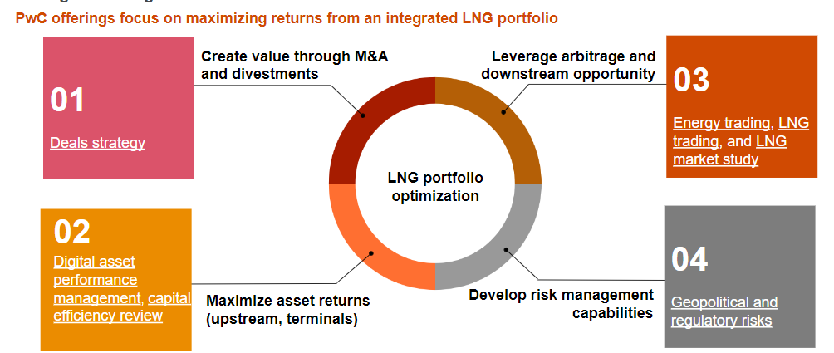

**Figure 3: M&A target selection, equity investment characteristics of an export LNG project**

### Key guidelines/framework adopted by LNG, equity players to invest in the target export project

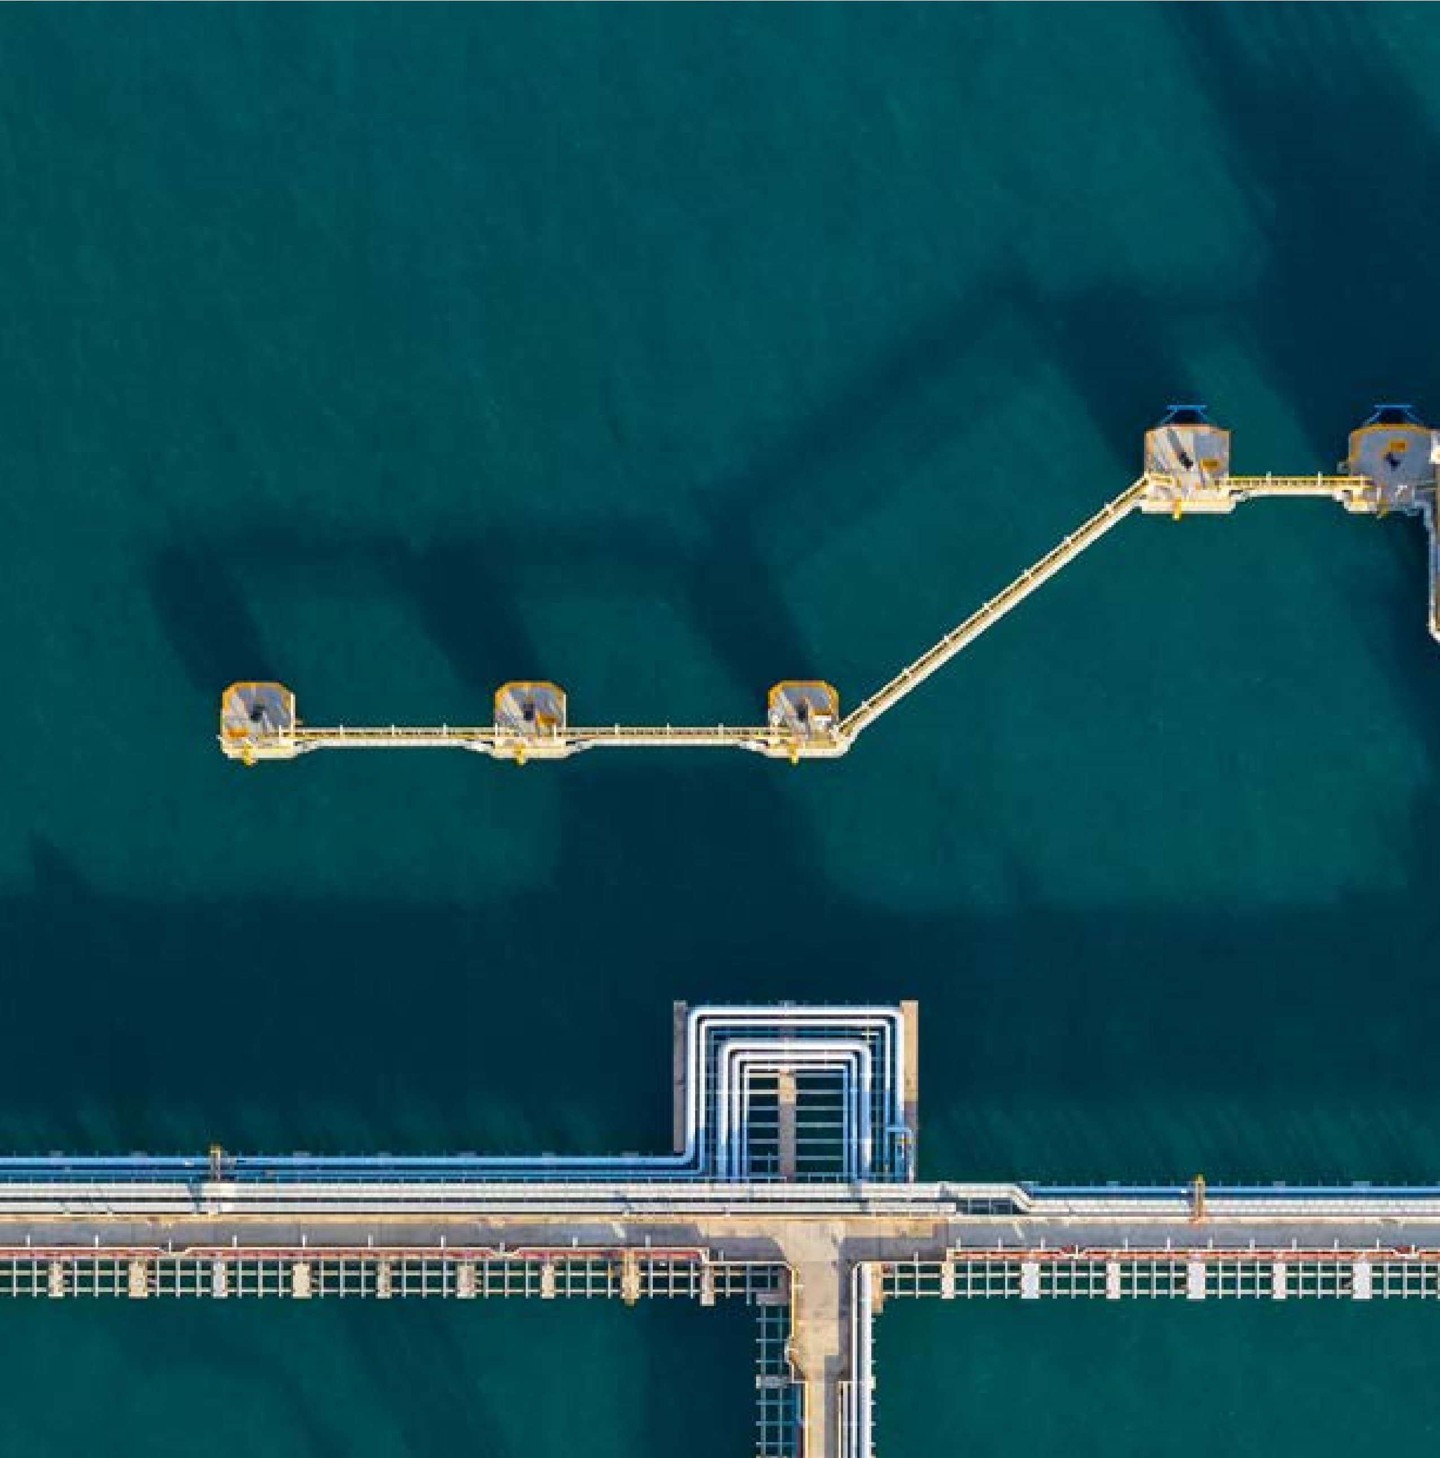

Conclusion

LNG players encounter many challenges related to production, projects and contracts . As a result,

prices have been impacted and the urgency to tackle these issues has increased dramatically. One way to address these

challenges is to accelerate the implementation of digitization strategies such as ETRM to help improve resilience and nnovation.

Adopting edge computing in the supply chain with transparent operating guidelines can be one such measure which

organisations can implement. With digital transformation strategies and solutions, organisations can seamlessly leverage agility

and efficiency to enable their enterprises to become adaptable for further growth.

About PwC

At PwC, our purpose is to build trust in society and solve important problems.

We’re

a

network

of

firms

in

152

countries

with

over

328,000

people

who

are

committed to delivering quality in assurance, advisory and tax services. Find out

more and tell us what matters to you by visiting us at

[www.pwc.com.](http://www.pwc.com/)

PwC

refers

to

the

PwC

network

and/or

one

or

more

of

its

member

firms,

each

of

which is a separate legal entity. Please see

[www.pwc.com/structure](http://www.pwc.com/structure)

for further

details.

© 2023 PwC. All rights reserved.

Contact us

Tushar Tiwari

**xxxxxxx**

,

Associate Director,

xxx, PwC India

Emerging Technologies, PwC US

xxxxxxxx@pwc.com

xxxxxx@pwc.com

**xxxxxxx**

Director

Emerging Technologies, PwC India

xxxxxxxx@pwc.com

Contributors

xxxxxx

xxxxxxxxxxxx

xxxxxx

xxxxxxxxxxx

xxxxxx

xxxxxxxxxxxx

pwc.in

Data

Classification:

DC0

(

Public

)

In this document, PwC refers to PricewaterhouseCoopers Private Limited (a limited liability company in

India having Corporate Identity Number or CIN : U74140WB1983PTC036093), which is a member firm of

PricewaterhouseCoopers International Limited (PwCIL), each member firm of which is a separate legal entity.

This document does not constitute professional advice. The information in this document has been obtained or

derived from sources believed by PricewaterhouseCoopers Private Limited (PwCPL) to be reliable but PwCPL

does not represent that this information is accurate or complete. Any opinions or estimates contained in this

document represent the judgment of PwCPL at this time and are subject to change without notice. Readers of this

publication are advised to seek their own professional advice before taking any course of action or decision, for

which they are entirely responsible, based on the contents of this publication. PwCPL neither accepts or assumes

any responsibility or liability to any reader of this publication in respect of the information contained within it or for

any decisions readers may take or decide not to or fail to take.

© 2023 PricewaterhouseCoopers Private Limited. All rights reserved.

SG/March 2023 - M&C 25697

1.
2. [https://www.spglobal.com/commodityinsights/en/market-insights/latest-news/electric-power/080420-bp-looks-to-double-lng-portfolio-by-2030-to-30-million-mtyear-cfo#](https://www.spglobal.com/commodityinsights/en/market-insights/latest-news/electric-power/080420-bp-looks-to-double-lng-portfolio-by-2030-to-30-million-mtyear-cfo)
3. <https://www.brecorder.com/news/40206865>
4. <https://www.argusmedia.com/en/news/2186162-shell-eyes-lng-expansion>
5. <https://totalenergies.com/infographics/totalenergies-integrated-player-lng-chain>
6. <https://www.energyconnects.com/news/gas-lng/2023/february/exxon-plans-trading-division-to-vie-for-commodity-profits/>
7. <https://www.trafigura.com/media/3531/2022_trafigura_annual_report.pdf>
8. <https://lngprime.com/europe/vitols-2022-lng-volumes-rise-on-european-demand/76708/>